PREDICTIVE ANALYTICS ASSIGNMENT

**SUBMITTED BY:**

SUKETHA.E

21MBMA14

MBA(GEN)

***APPOINTMENT SCHEDULING CHATBOT USING GOOGLE DIALOG BOX***

-

**These are the training phases I’ve used:**

* The bot is trained with these phrases.
* In this traing phrases, set an appointment is the sentence which acts as an intent here.
* Then the time(pm,am) and week names act as specifications(entities)

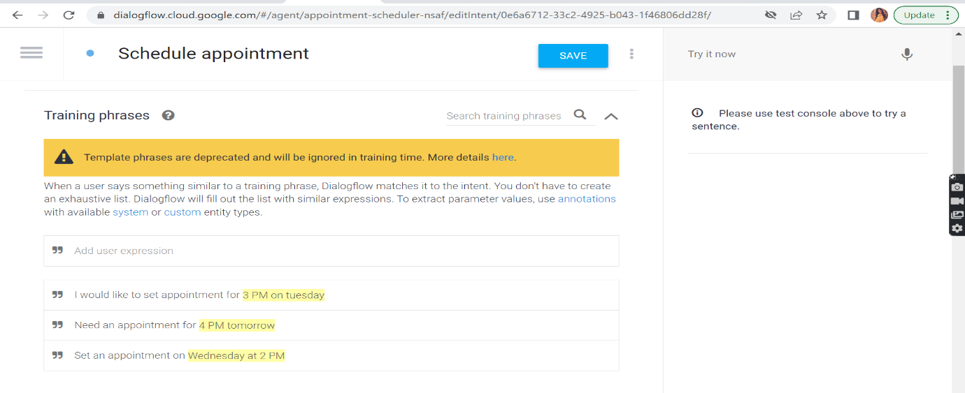**These are the action and parameters:**

* Here it is given as what a bot should mention or ask for when a customer asks for an appointment.
* After client asks for appointment, bot will first ask on what date?
* After getting to know the date bot will check and ask for the time. Then it confirms if you’re appointment is set or not.

**These are the responses given :**

* Once you give the enough information asked, bot will display the below mentioned response.

**Integrated Appointment Scheduler Chatbot:**

* After giving intents and entities, we’ll try to see the demo of our chatbot.
* This is it:

**My conversation with the robot:**

